**Rapid Application Development**

**230701221**

**M.Nithyashree**

**RAD (Rapid Application Development)** is a software development methodology that emphasizes quick development and iteration of prototypes over strict planning and long development cycles. It’s ideal for projects where requirements evolve through user feedback and where fast delivery is important.

**Key Characteristics of RAD:**

• Focus on prototypes instead of extensive documentation

• User involvement throughout the development process

• Fast development cycles with frequent iterations

• Reusable components to reduce effort

• Best suited for UI/UX-intensive projects like web and mobile apps

**Phase 1: Requirements Planning**

This is where the project goals, system requirements, and user needs are identified. Stakeholders, users, and designers collaborate to decide what needs to be built.

1. Identify Key Features

**Navigation:**

• Home

• Product Categories

• Product Listings

• Product Details

• Cart

• Order Confirmation

**User Actions:** Browsing, Searching, Adding to Cart, Checkout, Tracking Orders

**2) Create a Requirements Document:**

1. View list of product categories

2. View products under each category

3. View detailed information about a product

4. View and edit cart

5. Checkout and enter user/shipping/payment details

6. View order confirmation message

**Phase 2: User Design**

Designers and users collaborate to create wireframes and prototypes. The idea is to show how the application will look and behave before any actual coding starts.

**1) Tools Used**: Axure: Used to design the wireframes and UI prototype.

**2) Wireframes Designed:**

• Home Page: Highlights featured products and links to categories

. • Product Categories: Lists all product categories to explore

. • Product Listings: Shows products under a selected category.

• Product Details: Displays product info with "Add to Cart" option.

• Cart: Shows added items with price and quantity details.

• Checkout: Collects shipping and payment information.

• Order Confirmation: Confirms successful order placement.

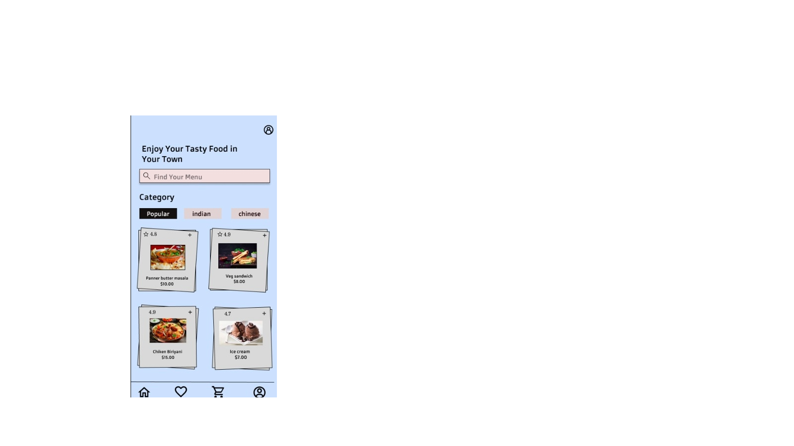 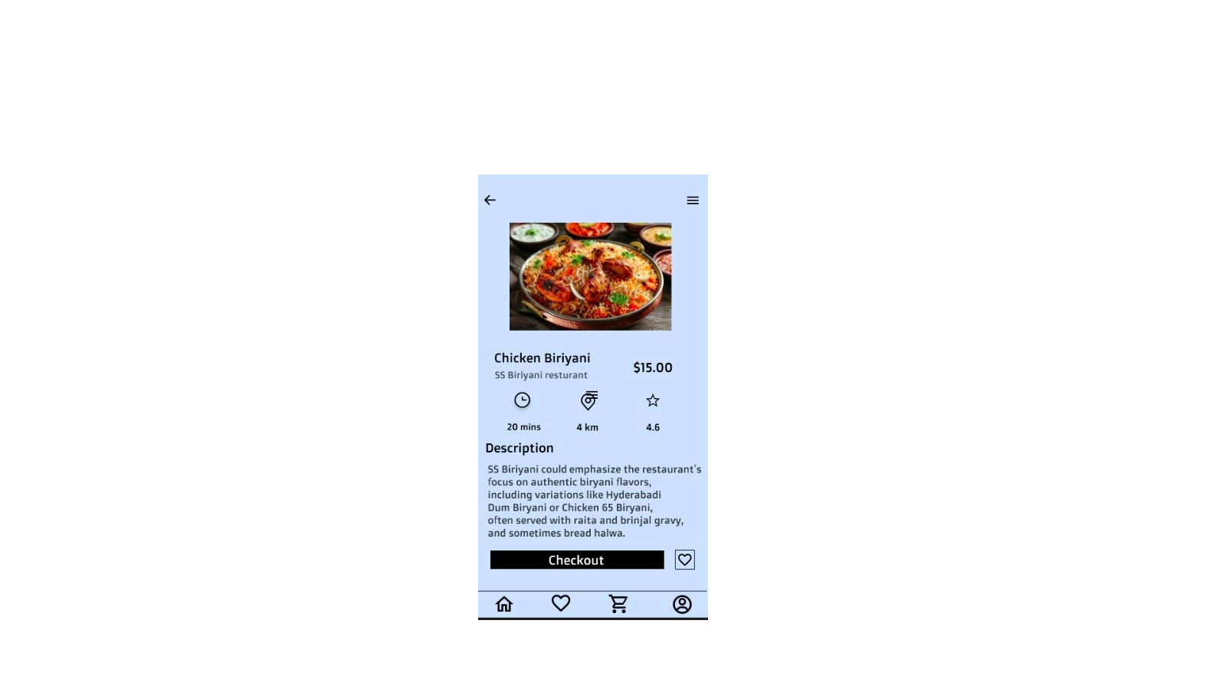

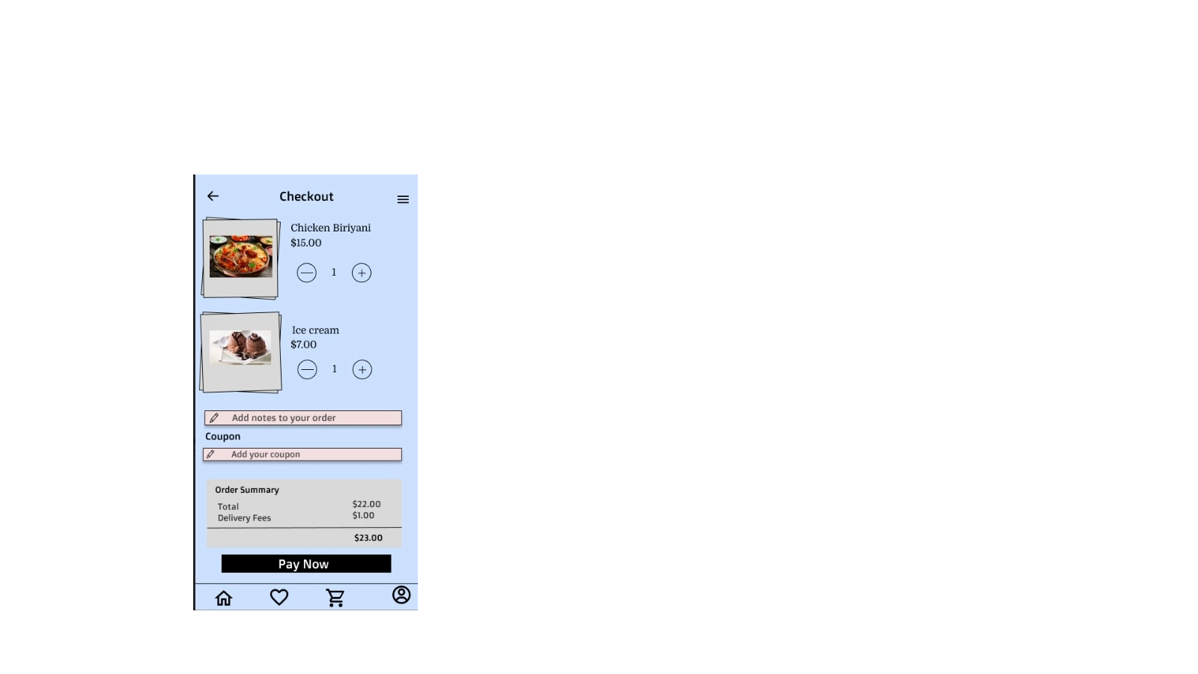

**Phase 3: Construction**

This is where the actual development happens, but in RAD, it is tightly coupled with ongoing testing and feedback. You refine the prototype based on user responses.

1. **Interactive Prototypes:**

• Created using Axure’s prototype linking features

• Functional paths designed: o From Home → Product Categories → Product Listings → Product Details → Add to Cart → Checkout → Order Confirmation

1. **Dynamic Elements:**

• Simulated transitions and modals for adding to cart and checking out.

• Screens simulate real-time behavior such as navigating between product listings and cart.

1. **Testing and Iteration**

• Prototype previewed with "Present" mode in Figma.

• Collected feedback from stakeholders (assumed for documentation).

• Iterated based on visual hierarchy, accessibility, and flow suggestions.

**Phase 4: Cutover**

In this final phase, the system goes live. This includes finalizing the design, training users, and preparing documentation for developers.

1. **Finalization and Export**

• Final design prototype shared through Figma link.

• Ready for hand-off to development team.

• Could be exported to HTML/CSS using plugins like Figma-to-HTML or further tools if needed.

**2) User Training & Support:**

• Walkthrough of the prototype for stakeholders or development team.

• Notes/documentation provided for developers to understand functionality and user flow.

• Easy access to Figma comments for further collaboration and questions.